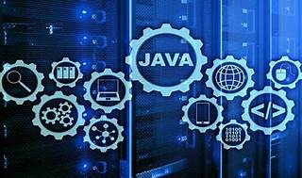

Explore

**Java** is a high-level, class-based, object-oriented programming language designed to have as few implementation dependencies as possible. [It allows programmers to write code once and run it anywhere, making it one of the most popular languages worldwide1](https://en.wikipedia.org/wiki/Java_%28programming_language%29)[2](https://www.w3schools.com/java/java_intro.asp)[3](https://www.geeksforgeeks.org/introduction-to-java/). Here are **five free resources** where you can learn Java:

1. **Programiz**: Offers step-by-step tutorials and examples for beginners. You can start with their [**Interactive Java Course**](https://www.programiz.com/java-programming).
2. **W3Schools**: Provides a comprehensive [**Java tutorial**](https://www.w3schools.com/java/) covering mobile apps, web apps, desktop apps, games, and more.
3. **Codecademy**: Their [**Learn Java course**](https://www.codecademy.com/learn/learn-java) is beginner-friendly and covers software development, web apps, and mobile apps.
4. **Wikibooks**: Explore the **Java Programming section** for in-depth knowledge.
5. **GeeksforGeeks**: Their [**Introduction to Java**](https://www.geeksforgeeks.org/introduction-to-java/) article provides a concise overview.

Happy coding! 🚀